Semester – IV
COURSE
CH-202: Physical and Inorganic Chemistry
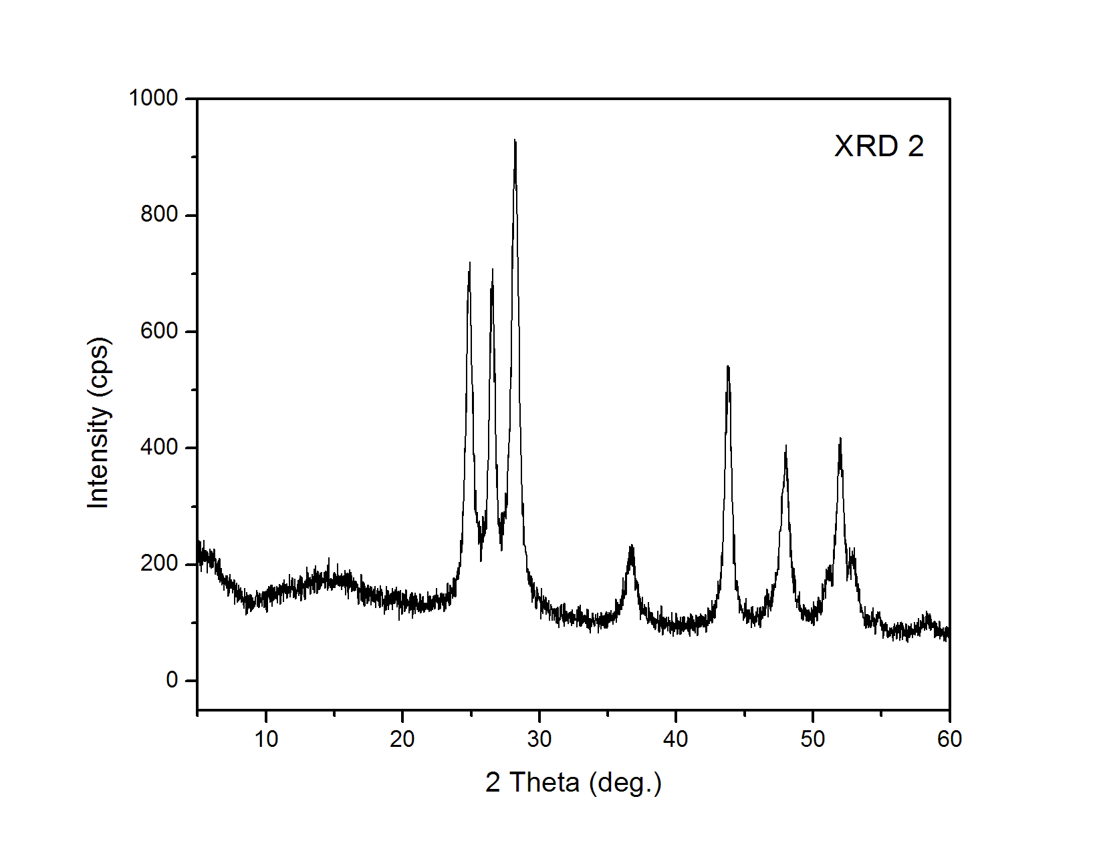
Section - I (Physical Chemistry)
XRD pattern of nanocrystalline CdS
COURSE SCHEDULE
DIVISION A
Alternate Monday (Time: 1.30 to 2.30 pm)
Every Saturday (Time: 1.30 to 2.30 pm)
Class room: B-304
DIVISION B
Every Wednesday (Time: 1.30 to 3.30 pm)
Alternate Monday (Time: 1.30 to 2.30 pm)
Class room: B-305
COURSE MARKS
ISA I (ASSIGNMENT) – 10 marks + ISA II (WRITTEN TEST) – 10 marks + SEE – 40 marks

SYLLABUS
SEMESTER – IV
CH – 202:Physical and Inorganic Chemistry
Section - I (Physical Chemistry)
I. Electrochemistry 12 L
Electrical transport –conduction in metals and in electrolyte solutions, specific conductance and equivalent conductance measurement of equivalent conductance, variation of equivalent and specific conductance with dilution. Migration of ions and Kohlrausch law, Arrhenius theory of electrolyte dissociation and its limitations, weak and strong electrolytes , ostwald’s dilution law its uses and limitations. Debye –Huckel-Onsager’s equation for strong electrolytes (elementary treatment only). Transport number, definition and determination by Hittorf method andmoving boundary method. Applications of conductivity measurements: determination of degree of dissociation, determination of ka of acids , determination of solubility product of a sparingly soluble salt, conductometric titrations .

II. Solid State 11 L
Defination of space lattice, unit cell. Laws of crystallography –(i) law of constancy of interfacial angels (ii) law of rationality of indices (iii) law of symmetry elements in crystals. X-ray diffraction by crystals. Derivation of Bragg equation. Determination of crystal structure of NaCl, KCl and CsCl (Laue’s method and powder method).

III. Colloidal State 07 L
Definition of colloids, classification of colloids. Solids in liquids (sols): properties –kinetic, optical and electrical; stability of colloids, protective action, Hardy- schulze law gold number. Liquids in liquids (emulsions): types of emulsions, preparation .Emulsifier Liquids in solids (gels): classification, preparation and properties, inhibition, general applications of colloids

Text Books
1. P.W. Atkins et al., Physical Chemistry, 7th edition
2. J.D. Lee, Concise Inorganic Chemistry, ELBS Publications, 4th Edition

Reference Books
1. Puri, Sharma, Pathania,Principles of Physical Chemistry by
Vishal Publishing Company, Oxford University Press
2. G. K. Vemulapalli, Physical Chemistry, Prentice Hall India, 1993,
3. Donald McQuarrie, Physical Chemistry
4. Bahl A., Bahl B.S. and Tuli G.D., Essentials of Physical Chemistry, S. Chand & Company Ltd., New Delhi, 1st Multicolor Revised Edition, 2009.
5. Raj G., Advanced Physical Chemistry, Goel Publishing House, Meerut, 21st Edition, 1996-97.

TENTATIVE SCHEDULE FOR SEMESTER IV
ACADEMIC YEAR 2015-2016
S. Y. B. Sc.
(CH - 202: PHYSICAL AND INORGANIC CHEMISTRY)
SECTION I
LECTURE NUMBER | TOPIC | REFERENCE | PAGE NUMBER
1 | Colloidal State  Definition of colloids, classification of colloids | 4  5 | 807-809  933-934
2 | Solids in liquids (sols): properties –kinetic, optical and electrical | 4 | 815-823
3 | Stability of colloids,  protective action, Hardy- schulze law gold number | 4  5 | 824-825  986-998
4 | Liquids in liquids (emulsions): types of emulsions, preparation. Emulsifier | 4  5 | 826-827  1011-1015
5 | Liquids in solids (gels): classification, preparation and properties, inhibition, General applications of colloids | 4  5 | 828-831  1003-1011
6 | Electrical transport –conduction in metals and in electrolyte solutions | 4  5 | 860-864  1107-1109
7 | Specific  conductance and equivalent conductance measurement of equivalent conductance,  variation of equivalent and specific conductance with dilution | 4  5 | 865-869  1110-1115
8 | Migration of ions and Kohlrausch law | 4  5 | 884-898  1116-1120
9 | Arrhenius theory of electrolyte dissociation and  its limitations | 4  5 | 883-884  1132-1135
10 | Weak and strong electrolytes | 4  5 | 871
11 | Ostwald’s dilution law its uses and  limitations | 4  5 | 909-911  1129-1132
12 | Debye –Huckel-Onsager’s equation for strong electrolytes | 4  5 | 911-914  1135-1145
13 | Transport number, definition and determination by Hittorf method and moving boundary method | 4  5 | 888-894  1179-1190
14 | Applications of conductivity measurements :determination of degree of dissociation ,  determination of ka of acids , determination of solubility product of a sparingly soluble  salt, conductometric titrations | 4  5 | 898-901  1118-1120
15 | Definition of space lattice | 4 | 447-453
16 | Unit cell | 4 | 452-456
17 | Laws of crystallography –(i) law of constancy of interfacial angels  (ii) law of rationality of indices (iii) law of symmetry elements in crystals | 4 | 449
18 | X-ray diffraction by crystals | 4 | 456
19 | Derivation of Bragg equation | 4 | - 456-461
20 | Determination of crystal structure of NaCl, CsCl, KCl | 4 | - 461-464

COURSE OBJECTIVE, INDICATIVE CONTENT AND LEARNING OUTCOMES
OBJECTIVE:
The main objectives of this course is to study
- Electrolytic conductance, its variation and applications
- Solid state chemistry, X-ray diffraction, principles and applications
- Chemistry of colloids, their properties and uses

INDICATIVE CONTENT:
The first topic ‘Electrochemistry’ deals with electrolytic conductance, its variation with dilution and theories of electrolytic dissociation. The applications of conductivity measurements form an integral part of this topic.
The second topic ‘Solid State’ deals composition of unit cell, space lattice and laws of crystallography. X ray diffraction method of characterisation of materials is also covered in this topic.
The third topic ‘Colloidal State’ deals with substances in particle size range of 1-100 nm. The topic covers classification, properties and applications of colliods.
LEARNING OUTCOMES:
Upon completion of Course students will be able to
1. Understand electrolytic dissociation, composition of materials in solid state and properties and applications of colloids
2. Draw conductometric titration graphs
3. Interpret X ray diffraction patterns

